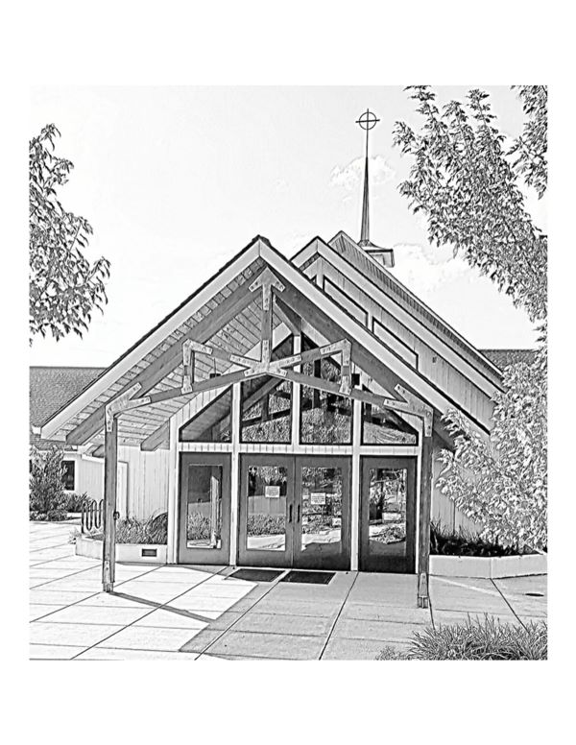
Fourth Sunday after Epiphany

January 29, 2023

10:30 am Worship Service
4595 SW California St.
Portland, OR 97219
503-246-2325
www.stlukechurch.com

Fourth Sunday after Epiphany |  |  |  |  | 10:30am |  |  | January 29 ,2023
Gathering
Prelude |  |  | This Is My Prayer |  |  |  | Edward Broughton |  | Annamarie Pearson
Welcome and Announcements |  |  |  |  |  |  |  |  | Pr. Patti Welch
Confession and Forgiveness
Blessed be the holy Trinity, ☩ one God, who makes all things new, whose mercy
endures forever. Amen.
Trusting in God’s mercy, let us confess our sin.
Silence is kept for reflection.
Holy One, source of our renewal, we confess that we are wrapped up in sin, and
cannot free ourselves. We have not practiced your righteousness. Our hearts have turned away from you. For the sake of the world you so love, forgive us, that we may be reconciled to one another for the glory of your holy name. Amen.
Thus says our God: “The former things have come to pass and new things I now
declare.” God’s mercy makes us new. We are forgiven in the name of ☩ Christ our Savior. Amen.
Gathering Hymn |  |  | O God of Mercy, God of Light |  |  |  |  |  | #714
Apostolic Greeting
The grace of our Lord Jesus Christ, the love of God, the communion of the
Holy Spirit be with you all. And also with you.
Prayer of the Day
Holy God, you confound the world’s wisdom in giving your kingdom to the lowly and
the pure in heart. Give us such a hunger and thirst for justice, and perseverance in striving for peace, that in our words and deeds the world may see the life of your Son, Jesus Christ, our Savior and Lord. Amen.
Word
First Reading: |  |  |  | Micah 6:1-8 |  |  |  | Karyn O’Bryant, reader
Word of God, word of life. Thanks be to God.
Anthem | My Soul’s Been Anchored in the Lord |  |  |  |  |  | Traditional Spiritual arranged by Moses Hogan |  |  | Rejoice Choir
Second Reading: |  |  | 1 Corinthians 1:18-31
Word of God, word of life. Thanks be to God.
Gospel Acclamation |  |  | Alleluia |  |  |  |  |  | Pg. 124
Rejoice and be glad, for your reward is great in heaven.
Gospel Reading: |  |  | Matthew 5:1-12 |  |  |  |  |  | Pr. Patti Welch
The Gospel of the Lord. Praise to you, O Christ.
Sermon
Sermon Hymn |  |  | Rise Up, O Saints of God! vs. 1, 3 & 5 |  |  |  |  |  | #669
Statement of Faith
We are not alone, we live in God’s world.
We believe in God: who has created and is creating, has come in Jesus, the Word made flesh, to reconcile and make new, who works in us and others by the Spirit.
We trust in God.
We are called to be the Church: to celebrate God’s presence, to live with respect
in Creation, to love and serve others, to seek justice and resist evil, to proclaim Jesus, crucified and risen, our judge and our hope.
In life, in death, in life beyond death, God is with us.
We are not alone. Thanks be to God.
A New Creed (1968; rev. 1980, 1995) © The United Church of Canada. Used with permission.
Prayers of the People |  |  |  |  |  |  | Dean Gustafson, prayer leader
Merciful God, receive our prayer.
Prayer Response |  |  | Let Streams of Living Justice vs. 1 |  |  |  |  |  | #710
Peace
The peace of Christ be with you always. And also with you.
The Offering
Offertory Music |  | This Holy Feast |  |  |  | C.B. Lysberg arranged by George Blake |  |  | Annamarie Pearson
Offertory Prayer
Liberating God, you break the bonds of injustice and let the oppressed go free.
Receive these offerings in thanksgiving for all your works of merciful power,
and shape us as people of your justice and freedom. You we magnify and adore, through Jesus our Savior, Amen.
The Sacrament of Holy Communion
Great Thanksgiving Dialogue |  |  |  |  |  |  | pg. 129
Preface
Holy, Holy, Holy |  |  |  |  |  |  | pg. 130
Words of Institution
…For as often as we eat of this bread and drink from this cup, we proclaim the Lord’s death until he comes:
Christ has died |  |  |  |  |  |  | pg. 131
Amen |  |  |  |  |  |  | pg. 131
Lord’s Prayer
Lamb of God |  |  |  |  |  |  | pg. 135
Communion Hymns
Hymn |  |  | Build a Longer Table
Hymn |  |  | What Does the Lord Require of You
Post-Communion Prayer
God our redeemer, you have fed us at this table with gifts of grace, truth, and life. As
you have gathered us in joy, send us forth as messengers of your peace. Make us shine with the good news of your glory, born to us in Jesus Christ, our Savior and Lord. Amen.
Benediction
Sending Hymn |  |  | Jesus, the very thought of you |  |  |  |  |  | #754
Dismissal
Go in peace. Follow the way of Jesus. Thanks be to God.
Postlude |  |  | Prelude in F |  |  |  | J.S. Bach |  | Annamarie Pearson

